# Object tracking flow

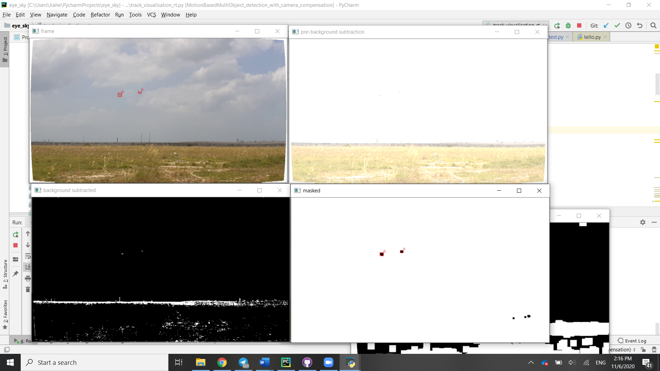

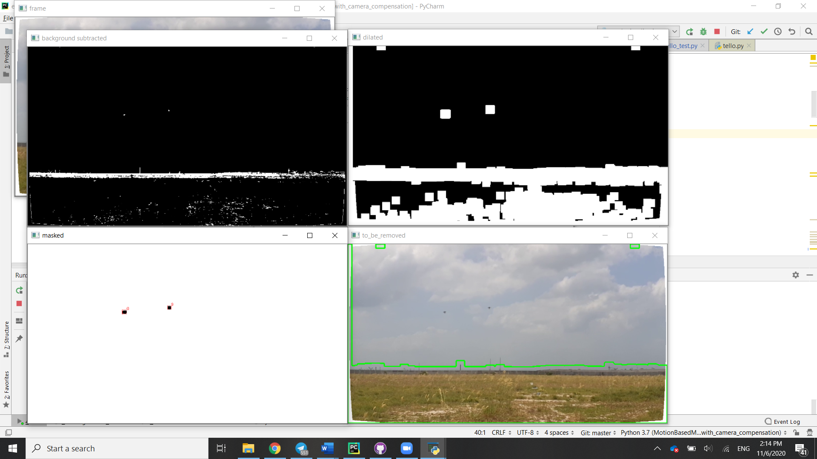

The images above give an outline of the output of each stage of the image processing step.



Figure Original frame (with tracks)

The object detection script is run on the input frame by frame. Image undistortion is first performed on the frame, resulting in the while border. Image stabilization is then performed by means of optical flow to identify how the camera frame moves in the global frame.



Figure Frame after brightness adjustment

The average brightness of the frame is obtained by finding the weighted sum of histogram values by bin. An inverse of the average brightness is taken and used to adjust the brightness of the scene. i.e. The values of all pixels in a frame with average brightness would be increased by 256 minus the average brightness plus some tuning constant, which effectively thresholds the image using a threshold value near the average brightness.



Figure Frame after background subtraction

The resultant frame is then subject to background subtraction using a Gaussian Mixed Model (GMM) with a history of 10 seconds and a background ratio of 0.05. This produces a frame with objects in the sky clearly visible with some degree of noise on the ground where the brightness is lower.



Figure Dilation lumps patches of noise together

Performing successive dilation on the image, areas of noise are grouped together, making them easier to filter out.



Figure Sections to be removed are surrounded by a green contour

To filter out sections of noise, contouring is performed on the dilated image. The parent contours, indicating the outlines of objects are then filtered based on their circularity, calculated as the ratio of their area to their parameter and compared to that of a circle. Objects with lower circularity likely originate from large irregular objects such as the ground or trees and are filled in to create a mask of areas to remove.



Figure Resultant frame after application of mask

Applying the mask on the result of background subtraction results in an image consisting of only the remaining objects. Dilation is then performed to make the objects easier to detect and blob detection is performed. After filtering out noisy detections, what is left are tracks arising from supposedly objects to be tracked.